EXPERIMENT 5:
COLOR-LEVEL HISTOGRAM ANALYSIS USING OPENCV

AIM
To write a Python function to analyze the histogram of the given input image based on color levels using OpenCV.

REQUIREMENTS
Software Requirements:
- Python 3.x
- OpenCV (cv2)
- Matplotlib
- Notepad
- Command Prompt
- Windows Operating System

PROCEDURE
- Install Python on the computer.
- Install OpenCV using the command pip install opencv-python.
- Install Matplotlib using the command python -m pip install matplotlib.
- Create a folder named opencv on the Desktop.
- Place the input image color_fruits.png inside the opencv folder.
- Open Notepad and type the Python program.
- Save the program as color_histogram.py inside the opencv folder.
- Open Command Prompt.
- Navigate to the opencv folder using the commands cd Desktop and cd opencv.
- Run the program using the command python color_histogram.py.
- The original image and its color histogram will be displayed.
PROGRAM
import cv2
import matplotlib.pyplot as plt
def analyze_histogram(image):
colors = ('b', 'g', 'r')
names = ('Blue', 'Green', 'Red')
for i in range(3):
histogram = cv2.calcHist(
[image], [i], None, [256], [0, 256]
)
plt.plot(histogram, color=colors[i], label=names[i])

plt.title("Color Histogram")
plt.xlabel("Color Intensity (0-255)")
plt.ylabel("Number of Pixels")
plt.legend()
plt.xlim([0, 256])
plt.show()
image = cv2.imread("color_fruits.png")
if image is None:
print("Image not found. Check the file name.")
else:
cv2.imshow("Original Image", image)
analyze_histogram(image)
cv2.destroyAllWindows()

INPUT
The input image used in this experiment is color_fruits.png, which contains fruits with different colors.
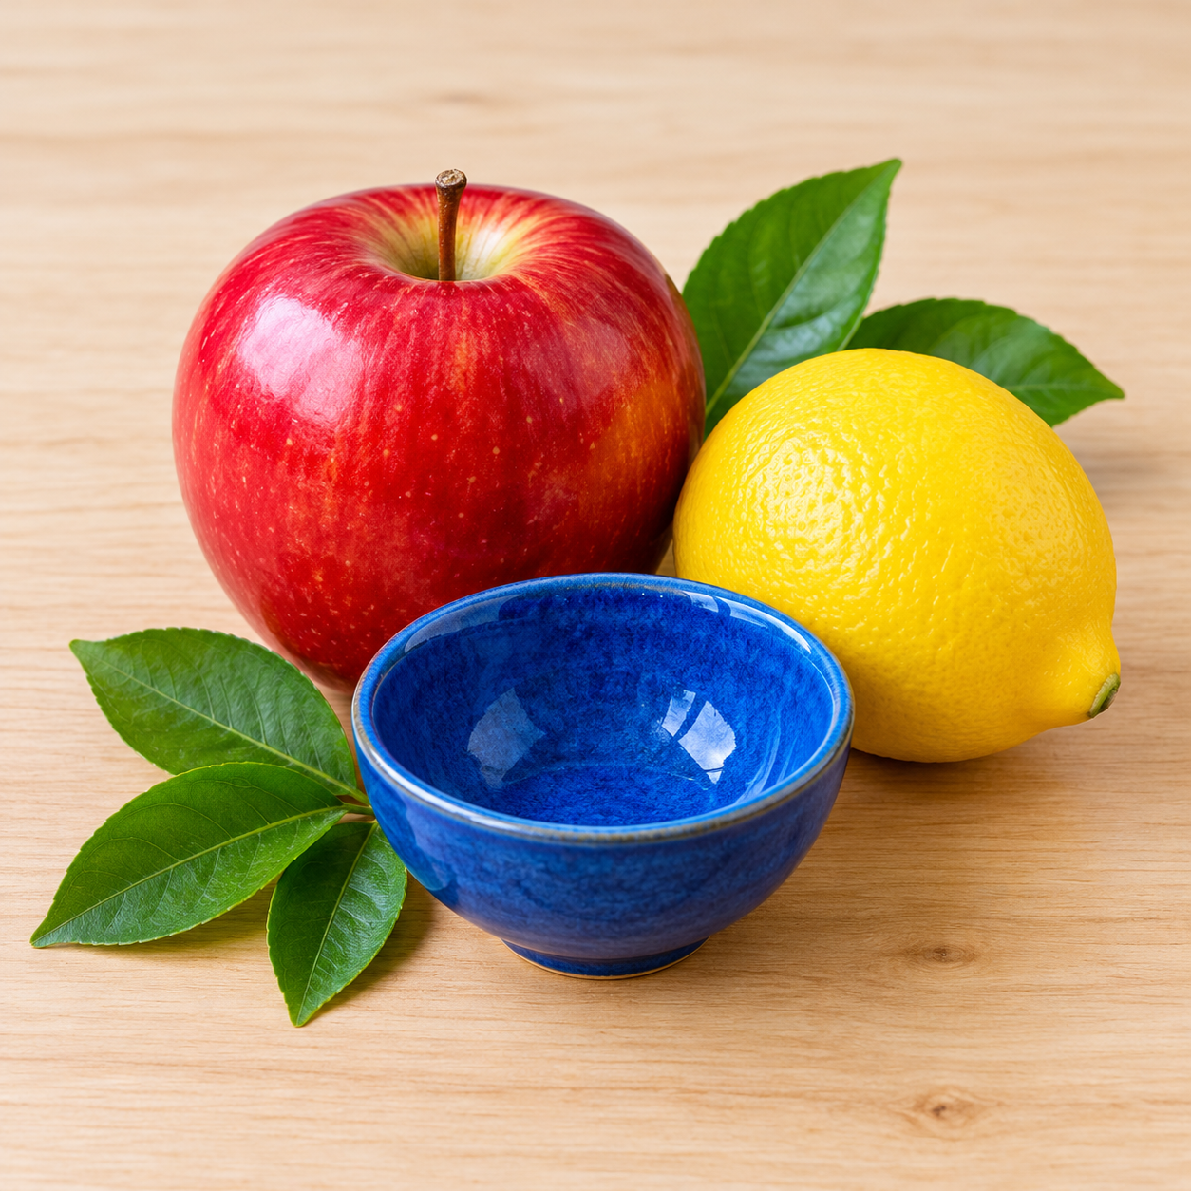

OUTPUT
The original fruit image and a color histogram showing the Blue, Green, and Red color intensity levels are displayed.
